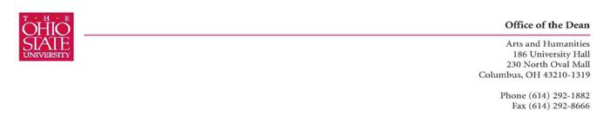

October 13, 2009

Dear Stafford and Dick ,

The Committee on Curriculum and Instruction’s Arts and Humanities Subcommittee met on October 6th and discussed the NELC 358 course “Sufism.” We unanimously approved it. After some discussion, we thought it might have application to the religious studies program, and we have notified the Center for the Study of Religion about this course.

Thank you for your commitment to undergraduate education at OSU,
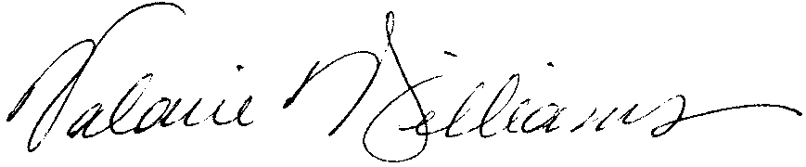
Valarie Williams
Chair, CCI Subcommittee B Arts and Humanities
Professor of Dance
Associate Dean, Arts and Humanities
Cc: Sarah Iles Johnston

